GUIDELINES FOR THE PROPER POINTING OF
GREGORIAN CHANT PSALM TONES

Pointing Gregorian Chant psalm tones is a matter of very simple mathematics as well as aligning flowing natural word stresses as we point to where to move the singers from the reciting pitch (the whole note at the beginning and the middle of the printed chant melodies below) to the moving pitches that follow it. As you will see in the samples below, Gregorian psalm tones are divided into two musical phrases that are divided by a single bar line (|) in the middle of the chant and which end with a double bar line (║) at the end of the chant. A point (׀ ) tells the singers when to move from a reciting pitch, the whole note found at the start of each of the two musical phrases, to the moving pitches that follow. In this manner, the bar lines and point symbols act as a simple road map that are reflected in both the music printed above the psalm text as well as in the psalm text itself.

An ending note on either side of the chant melody that is in ( ) means that the note is optional, only used as needed to aid in the natural flow of the sung text. This system of effective chant notation I devised after much testing and helpful feedback from my choirs and one that I have now employed both in the pointing of the Simplified Anglican Chant psalms (Years A, B, & C) for The New Coverdale Psalter as well as the Gregorian Chant psalms all found on the ACNA Music Resources website under the Psalms tab.

Note: If you download the Gregorian Chants Year B file found under Psalms on the ACNA Music Resources website, instructions can be found there on how to effectively teach Gregorian Chant to a congregation as well as and history and use information at the top of the document.

Let’s get down to the practice of pointing a Gregorian Chant psalm tone. Psalm 123, the first sample below, is set to Tone 4.4. That simply means that this is chant tune number 4 of the 8 that Pope Gregory codified, and that the tail on the melody is version 4, hence Tone 4.4. Many of the Gregorian Chant psalm tones have multiple melody tails to chose from. I chose some of the best of them and the easiest to sing for the ACNA Music Resources website New Coverdale psalms collection.

Begin by placing the bar lines, single and double, within the psalm text. See how I have done this below, it is consistent and predictable. I then begin to point (׀ ) the Psalm starting with the first half of each verse and point all of the first half of the verses first before moving onto the second half of each verse.

You will see with the music that I chose for Psalm 123 below (Tone 4.4) that in the first half of the sung chant there is a reciting pitch, a whole note, followed by a pointing symbol which says we change pitch now, which is then followed by four notes. It is these four notes that tell you where to place the pointing symbol (׀ ) and where your work is to be done. Count back three syllables from the end of the first line and place your pointing symbol (׀ ) there. Now sing the chant and see if the word stresses flow and seem smooth and natural. Counting back three syllables will work for us in the first half of stanza one. It will not work, however, for the first half of stanza 5… scorn of ׀ the wealthy. Sing it with the pointing at three syllables back and see how unnatural it sounds. Now put the pointing symbol four syllables back and sing it…scorn ׀ of the wealthy. Now it flows more naturally and the note in ( ) now shows us its value within the chant melody. Practice pointing in this manner and you’ll soon get the flow and beauty of it all.

Now move on to working the second half the each of the stanzas. You’ll note with this Psalm Tone (4.4) that there are five notes after the reciting pitch in the second half of the chant music. Count back five syllables from the end of the second stanza of each verse and place your pointing symbol (׀ ) there. This will work pretty solidly as there is no note in ( ) that has to be dealt with here.
And finally, I look at stanzas that are particularly long and need a breath to be navigated successfully. I place breath mark ( ’ ) in those places but do so sparingly as Gregorian Chant needs to flow and not to be broken up too often so that is can maintain its beauty and flow.

You will find that these pointing guidelines work for all of the Gregorian Psalm tones given below, simple mathematics and aligning natural flowing word stresses, and should allow both priests and church musicians to point the psalms for the Daily Offices as needed.

Mark K. Williams
Christ Church Anglican (1733)
Savannah, Georgia

Psalm 123 (Prayer in Distress)

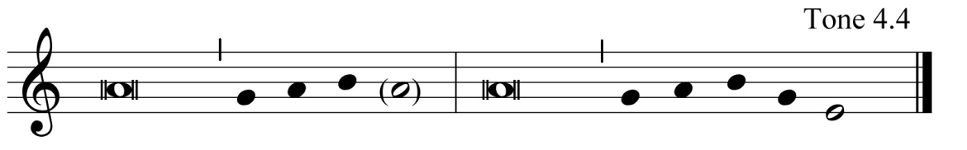

1 Unto you I lift ׀ up my eyes, |
you who are en׀ throned in the heavens. ║

2 Behold, as the eyes of servants look to the hand ׀ of their masters, |
and as the eyes of a maiden to the׀ hand of her mistress, ║

3 Even so our eyes wait upon the ׀ Lord our God, |
until he ׀ show us his favor. ║

4 Have mercy upon us, O Lord, have mer ׀ cy upon us, |
for we have suffered more ׀ than enough contempt. ║

5 Long has our soul suffered the scorn ׀ of the wealthy |
and the spite׀ fulness of the proud. ║

Psalm 112 (Praise of the Upright)

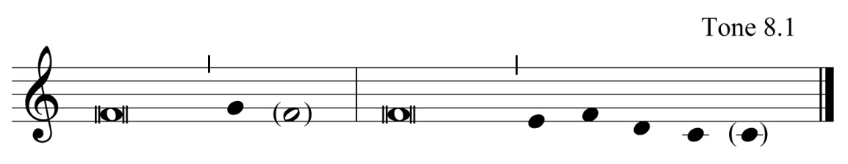

1 Praise the Lord! Blessed is the one who fears the׀ Lord, |
who has great delight in ׀ his commandments. ║

2 His seed shall be mighty in the ׀ land; |

the generation of the faithful ׀ shall be blessed. ║

3 Riches and plenteousness shall be in his ׀ house, |
and his righteousness shall en׀ dure forever. ║

4 For the upright, there rises light in the ׀ darkness; |
he is merciful, lo׀ ving, and righteous. ║

5 It is good for him to be generous in ׀ lending |
and to guide his words ׀ with discretion. ║

6 For he shall never be ׀ moved, |

and the righteous shall be kept in everlast׀ ing remembrance. ║

7 He will not be afraid of any evil ׀ tidings, |
for his heart is steadfast and ׀ trusts in the Lord. ║

8 His heart is established, and will not ׀ fear; |
at the last he shall see his desire ׀ upon his enemies. ║

9 He has given freely to the׀ poor, |

and his righteousness endures for ever; ’ his horn shall be exalt׀ ed with honor. ║

10 The ungodly shall see it, and shall be ׀ angry; |
he shall gnash his teeth, and waste away; ’ the desire of the ungod׀ ly shall perish. ║

Psalm 22:23-31 (The Sufferings and Hopes of the Upright)

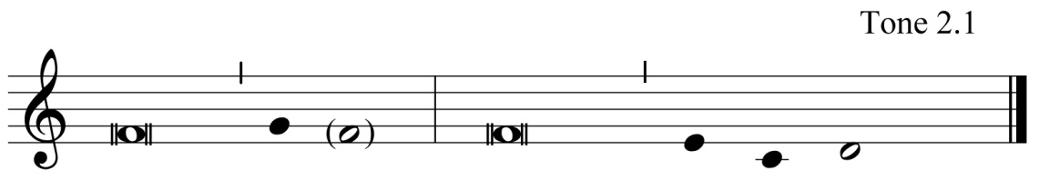

23 O praise the Lord, you that ׀ fear him; |
magnify him, all you seed of Jacob, ’ and fear him, all you seed of ׀ Israel. ║

24 For he has not despised nor abhorred the low estate of the ׀ poor; |
he has not hidden his face from him, ’
but when he called unto him, ׀ he heard him. ║

25 My praise is of you in the great congre׀ gation; |
my vows will I perform in the sight of those ׀ who fear him. ║

26 The poor shall eat and be satis׀ fied; |
those who seek after the Lord shall praise him; ’
may your hearts ׀ live forever. ║

27 All the ends of the world shall remember, ’ and be turned unto the ׀ Lord, |
and all the families of the nations shall worship ׀ before him. ║

28 For the kingdom is the׀ Lord’s, |
and he is the Governor a ׀ mong the peoples. ║

29 All those who sleep in the earth, how shall they worship׀ him? |
All those who go down into the dust, ’ how shall they kneel ׀ before him? ║

30 But my life shall be preserved in his sight, ’ and my children shall worship ׀ him; |
they shall tell of the Lord to the genera׀ tions to come; ║

31 And to a people yet unborn shall they declare his ׀ righteousness, |
that he has brought ׀ it to pass. ║

