Tips on Buying a Piano from

The Piano Technician’s Guild

(article begins on page 2)

A quality well-built, well-voiced acoustic piano is preferred by most all musicians. Imagine being handed an old trumpet with lots of dings and a bent mouthpiece. This is what is meant by a “clunker of a piano” and sadly, our churches are full of them. No doubt, you will find that there are a lot of very well intentioned loving church members who have an old piano they would like to donate. Know this, just because it is free, doesn’t necessarily mean that it is a good or appropriate instrument. Unlike some violins, pianos do not improve with age and much like an automobile, they are never any better in their life span than when they first leave the showroom. And yes, we have had some very nice instruments donated to the church over the years. We have also had a professional piano technician check them out and had the church musician play them before agreeing to pay to have them moved to the church for use in leading praise to God.

Generally, the rule is that it is better to have no piano than a bad one because once you accept the gift of a bad one, you are stuck in the “isn’t it good enough?” and “you know that was given in memory of” place. In this light, I encourage you to keep reading and learning, as a good piano correctly sized to the room in which it will be played has the potential of becoming a formidable leading presence in the worship life of a congregation and its music ministry.

Mark Williams, Christ Church Anglican (1733), Savannah, GA

SOURCE:
www.ptg.org › userfiles › file › Piano_Buying_Tips

Q. What is the first step towards purchasing a piano?
A. Purchasing a piano can create a lifetime of enjoyment. Before you spend money for either a new or used piano, a little preparation is helpful so that you purchase a piano that is appropriate for your needs and will insure your family's musical success. The first step in choosing a piano involves establishing your musical and furniture needs to fulfill your dreams. A piano will provide elegance, sophistication and beauty, so you want an instrument that will play properly and compliment your home's décor. Musically, you need to select a piano that has the key touch and musical tone that you like. The best way to accomplish this is to visit your local retail piano dealer. Find a dealer that has a large selection of new and used pianos at various prices. It is important that you sample or have the salesperson demonstrate a wide variety of pianos. When you play each piano, discover which piano keyboard has the touch most responsive to your fingers. Listen to many pianos to discover which tone is most appealing. You will also have an opportunity to view different cabinet and finish styles so you can select a piano that is attractive in your home. Once you discover what you want to purchase, and have an idea of the cost, you can either purchase a new or used piano from the retail dealer or attempt to locate a used piano privately.
Q. What are the differences between buying a piano from a retail dealer or a private individual?
A. When purchasing a new or used piano from a retail dealer, you'll find:
- new pianos usually come with a manufacturer’s warranty, a complimentary tuning, moving, and more cabinetry and finish choices.
- used pianos are generally reconditioned, and they usually come with a dealer warranty, moving and complimentary tuning.
- many dealers have a trade up policy that will give you the full purchased price of your piano when you desire a higher quality piano.
- you can expect to pay a little more for the manufacturer’s warranty, and the advantage of selecting a piano from a wide variety of new and used instruments.
To locate and purchase a piano privately, look in the newspaper classified ads. The Internet also has some opportunities for locating a piano. The best way to locate a used piano is to find a Registered Piano Technician (RPT) in your area. Often they are aware of used pianos for sale, and more importantly are aware of the piano's condition. If you are determined to locate a piano on your own, you are at risk buying a piano without having a Registered Piano Technician (RPT) evaluate the condition and appraise the value of the piano.
When purchasing a used piano privately, you'll find:
- they are generally less expensive than retail, assuming the seller has a realistic understanding of the value and condition of their piano.
- your search requires extra travel to several homes to locate a suitable piano.
- there is no warranty.
- the moving cost is usually the responsibility of buyer.
- less selection in furniture cabinetry and finish.
- that extra service is often required to restore the piano's touch and tone .
Despite the obvious drawbacks and hidden costs of purchasing a used piano privately, you can still do fine as long as you allow a Registered Piano Technician (RPT) act as your guardian angel to guide you through this potentially confusing purchase. Although it is possible for a technician to make some recommendations by telephone on site evaluations are good investments and can prevent costly errors.
Q. How can I tell if a used piano is in good condition?
A. Often problems that don't seem that big are major problems and vice versa. Keys that don't play are usually not a big problem. Often something has broken or come unglued which is easily fixed. There are a few older pianos with old plastic action parts that are problematic.
Look for notes that sound terribly out of tune when played by themselves. Most of the piano has three strings per note. The strings wrap around a steel tuning pin which is set into a wooden pinblock. When the pinblock goes bad it can't hold the tuning pins tightly and a tuning pin will slip. This leaves one of the three strings very flat to the others. This is not just an out of tune honky-tonk sound, but it will sound like you are playing two distinct notes. A bad pinblock may very well be the end of that piano if it is not a good enough piano to warrant rebuilding. On a high quality piano it may be worth doing a major rebuilding to replace the pinblock as these pianos are considerably more expensive if purchased new and would therefore warrant the work.
Another serious problem is the presence of strange rattles or buzzes. The soundboard, which is the large wooden board you can see from the back of an upright piano or from underneath a grand, has ribs glued on it to strengthen it. Sometimes when the soundboard gets cracks in it the ribs come unglued from it in places. This can allow the soundboard to rattle against the loose rib as it vibrates. This can sound like a speaker distorting when it is played too loudly. Pianos have a wooden bridge which is attached to the soundboard and has the strings running over it. The bridges have two pins for each string to hold the strings in place. Because there are so many pins very close together, sometimes the bridges split and allow the pins to become loose. This allows the strings to rattle against the loose pins. Bridges are often made in sections that can come unglued from each other also causing buzzes and rattles.
Look at the hammers for deep grooves cause by the strings. Layers of felt can be removed to restore the rounded shape to the hammer but eventually there in not enough felt left above the wooden molding to get a good tone. The high treble has the least amount of felt and you can sometimes see that the felt is all the way worn through and that the wood molding is actually striking the strings. Hammer replacement is fairly expensive and the piano needs to be good quality to warrant this work. You can't just replace the felt on the hammers. The felt is put on the moldings in special presses under tons of pressure.
The most important thing is to call a Registered Piano Technician to look at a piano before you buy it. You should look at the piano first and be sure it is something you are interested in. “Free or “cheap” pianos can actually be the most expensive if the condition of the instrument will require complete rebuilding in order to be a playable instrument. Ask your RPT to check out the structural condition of the piano. An investment of a service call before buying it can keep you from buying and moving a piano that won't be playable much less an instrument you can be proud to play and own.

IF YOU DECIDE TO GO THIS ROUTE, SOME QUALITY DIGITAL KEYBOARDS THAT WILL NOT DISAPPOINT
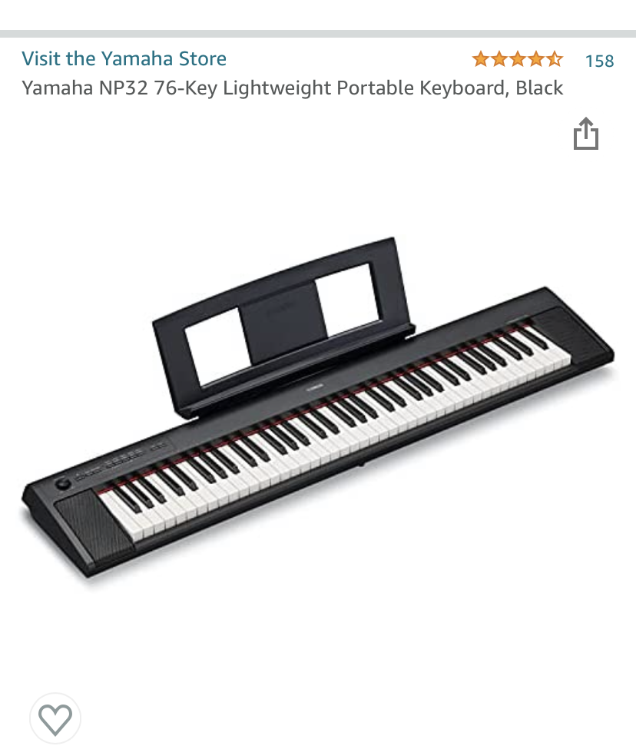

The Yamaha NP32 76-Key midi keyboard above is a surprisingly excellent keyboard. Plugged into a good sound system to a set of dedicated powered speakers it has some very fine keyboard samples included with the keyboard. The touch is highly responsive and the Grand Piano samples are superb. . For an 88-Key version of this keyboard see the photo below.
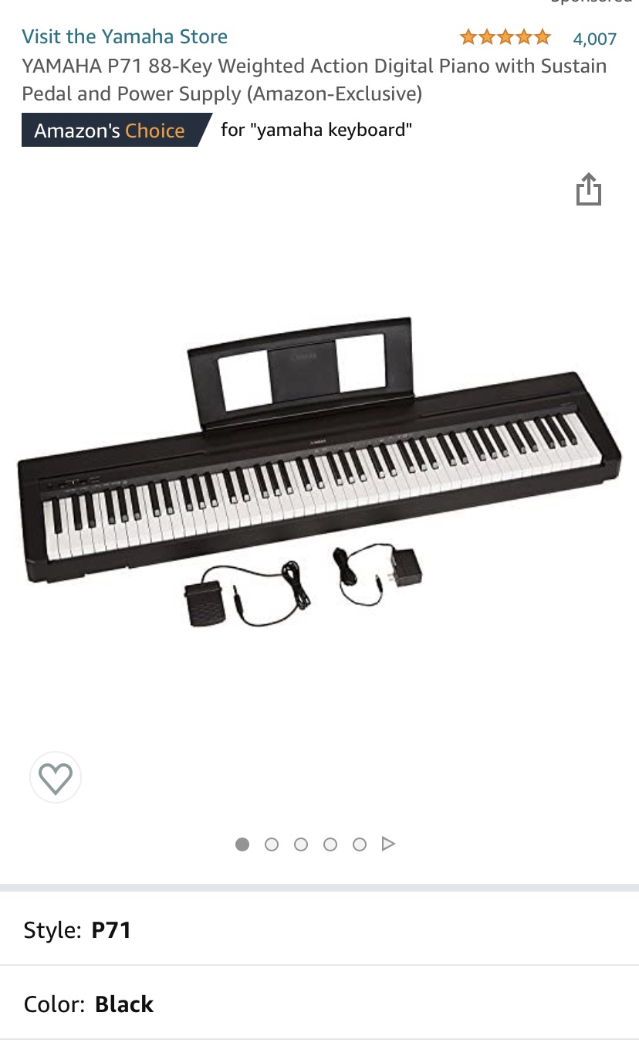

Below is the Casio Privia PX-770. Our church owns two of these and one of the Yamaha’s above. We like them equally well as they have good keyboard touch and excellent piano samples on board. The built-in speakers on the Casio are far better than those on the Yamaha and we often use them without additional amplification. On the other hand, the Yamaha keyboards pictured above are less expensive but not lower in quality as the on-board sounds are excellent as well. However, you will need to run them through larger/better speakers than the ones that are built into the instrument for use with a congregation or ensemble singers.
