HOW TO POINT PSALM TEXTS
FOR SIMPLIFIED ANGLICAN CHANT

Pointing Simplified Anglican Chant is dependent on getting in touch with word stresses within each line of the Psalm text (not the same with pointing Gregorian Chant, whole different ball of wax). When pointing the text for use with Simplified Anglican Chant first, sing the Psalm text line with the music that you have chosen for the Psalm in your head, or read it to yourself as if reading good poetry. While doing this, work to discern and feel where the natural word or syllable stress for the end of each line falls. This gets easier with practice. The lines within Psalm texts move toward the final word/s of each line as they typically answer what the line is conveying. (e.g. We have come into His courts with what? > praise. For we have suffered more than enough what? > contempt.) This is in contrast to hymn texts, where the keystone word is most often found in the middle of each line of text. With we sing hymns, we properly phrase toward the middle of each line, with the arch of the musical phrase forming an even bow shape above. However, when we sing Psalms, we phrase to the final words or syllables of each line with a hairline crescendo shape to the phrasing, bringing all of the meaning in the words to a culmination in the end of each line.

Here are some correct Psalm pointing samples for Simplified Anglican Chant. Note, that I have bolded the stressed word or syllable for illustrative purposes.

We have come into His courts with ׀ praise (or)
Lord, have mercy up ׀ on us, (or)
For we have suffered more than enough con ׀ tempt.

In contrast, sing or speak these same lines with poor pointing choices (as below) and you'll see what I mean when it doesn’t quite work. You'll now feel what shifting the stressed work or syllable to the wrong one does to the flow of the line. It creates an unnatural bump in the road.

We have come into His courts ׀ with praise (or)
Lord, have mercy upon ׀ us, (or)
For we have suffered more than enough ׀ contempt.

After you have pointed the Psalm lines in this manner, notice in the sample below that the bar lines at the end of each line correspond with the bar lines in the music. They follow a simple and consistent pattern. I also place breath mark ( ’ ) within particularly long lines of text to help the singers successfully navigate them. And finally, if there are an odd number of verses to the Psalm, I place the simple instruction (repeat second half of chant) prior to the final verse.

(See correct pointing sample below)

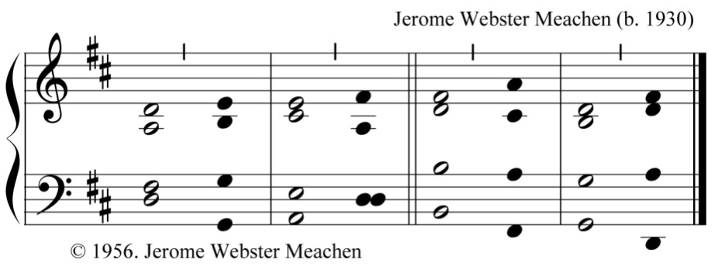

14 He divided the sea and let them go ׀ through; |
he made the waters to stand in a ׀ heap. ‖

15 In the daytime he led them with a ׀ cloud, |
and all the night through with a light of ׀ fire. ║

16 He split the hard rocks in the ׀ wilderness |
and gave them drink in abundance, as out of the great ׀ deep. ‖

17 He brought waters out of the stony ׀ rock, |
so that it gushed out like the ׀ rivers. ║

18 Yet for all this they sinned more a ׀ gainst him, |
and provoked the Most High in the ׀ wilderness. ‖

19 They tested God in their ׀ hearts |
and demanded food for their ׀ craving. ║

20 They spoke against God, ׀ saying, |
“Can God prepare a table in the ׀ wilderness? ‖

21 Indeed, he smote the stony rock, so that water gushed out, ’ and the streams over ׀ flowed; |
but can he give bread also, or provide meat for his ׀ people?” ║

22 When the Lord heard this, he was full of ׀ wrath; |
so a fire was kindled against Jacob, ’ and there flared up fierce anger against ׀ Israel, ‖

23 Because they did not believe in ׀ God, |
and did not put their trust in his ׀ help. ║

24 So he commanded the clouds a ׀ bove |
and opened the doors of ׀ heaven. ‖

25 He rained down manna upon them to ׀ eat |
and gave them food from ׀ heaven. ║

(repeat second half of chant)

26 So mortals ate the bread of ׀ angels; |
for he sent them food e ׀ nough. ║

(All four chants used on the ACNA Music Resources website below.)

THE FOUR SIMPLIFIED ANGLICAN CHANTS CHOSEN FOR
THE NEW COVERDALE PSALTER ON THE
ACNA MUSIC RESOURCES WEBSITE

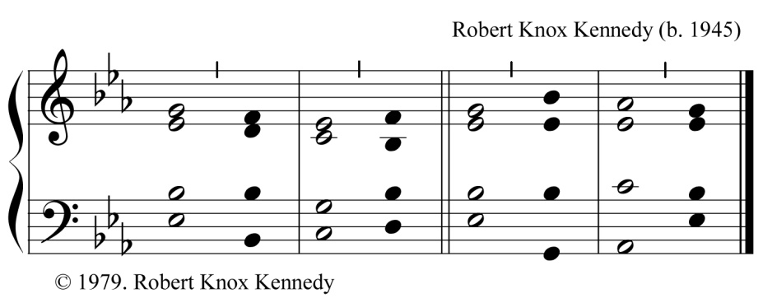

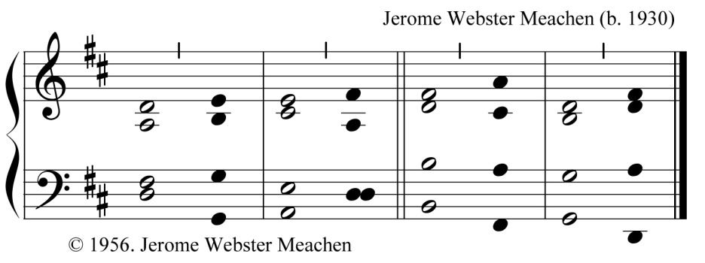

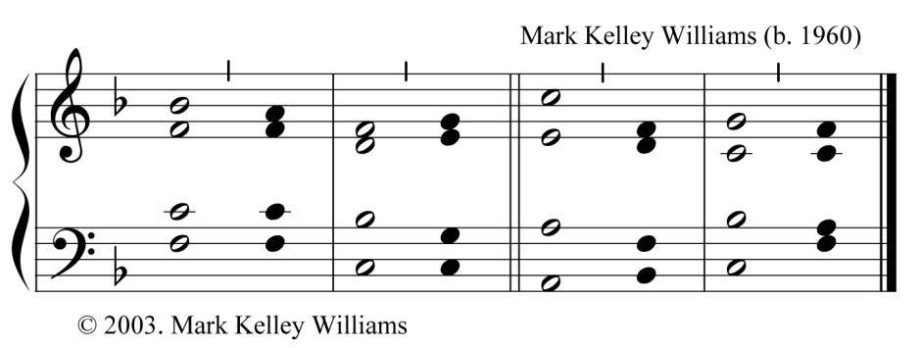

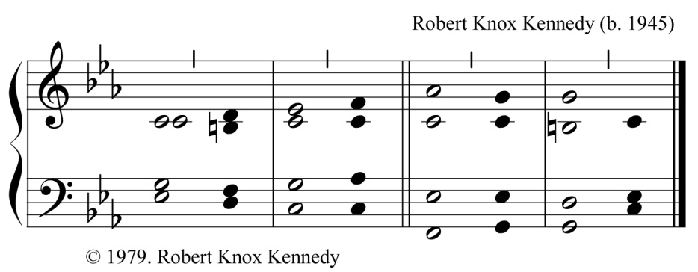

Mark K. Williams, Christ Church Anglican (1733), Savannah, GA

