Creating a Digital Orchestra

Our Anglican church has had the fortune of having many proficient High School and Adult wind and string players become a part of our Folk Group/Praise Team over the years. After many years of experimentation, the instruments that have worked well in playing melody, harmony, obbligato’s, and descants have been flutists, violinists, oboists, clarinetists, cellists, trumpeters, and French Horn players.

However, when a qualified live player is not available, we have supplemented the group’s sound with a keyboardist playing a Digital Orchestra and this has worked very well for us. These symphonic melodic instruments have added much to our congregation’s singing as well as to our adult and children choir’s sound. Furthermore, the trumpet samples added to live timpani and organ are really wonderful. The sounds are outstanding (London Philharmonic principle players sampled) and are highly refined and expressive. After much trial and error, here is what has worked for us. (see photos below)

Purchase the following and hook it together:

A digital keyboard and stand with plug-n-play USB MIDI input. (see recommendations below)

A Window’s tablet running Windows 10 with a USB port and at least 4GB of RAM. (Mount the tablet on the top end of the digital keyboard with Velcro.)

A copy of EAST/WEST’s Symphonic Orchestra’s SILVER EDITION ORCHESTA (EWQLSO SILVER COMPLETE 16-BIT) downloading and using their very good PLAY application for live performance (license required) on the Window’s tablet. (These digital samples will astound you and after reading the instructions and some experimentation, the use of the Player app. will become second nature.)

Two powered speakers from Behringer: B2031A active 2-Way Studio Monitors (high-quality, cost-effective, powered speakers. You can find quality used ones on Ebay.) The Behringer B2030A powered speakers also work well. They are a slightly smaller version but sound very good. Just be certain to order the model numbers ending with an “A” for active and not a “P” for passive/non-powered speakers.

A mini-stereo out male connector from the Windows tablet’s audio output to two ¼” audio male connectors to run to the two speakers. I would get 20-foot cables or more. Determine where you speakers are going to be located in the room allowing for adequate stereo channel separation and let that determine the length needed for your two cables. (Note: we turn the speakers 180 degrees around so they are not directly facing the congregation and so that they reflect off of a wall. This allows the sound to develop some in the room before getting to the ears of the congregation.)

A powered USB multi-port hub for connecting the keyboard, East/West orchestra license dongle, etc. to the tablet.

—Mark K. Williams, Christ Church Anglican, Savannah, GA

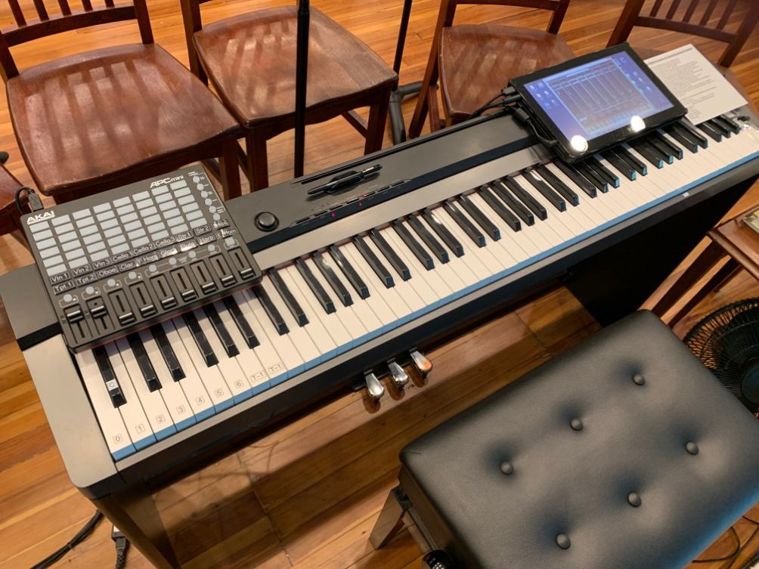

Our digital orchestra set up. Very realistic musical solo orchestral sounds.
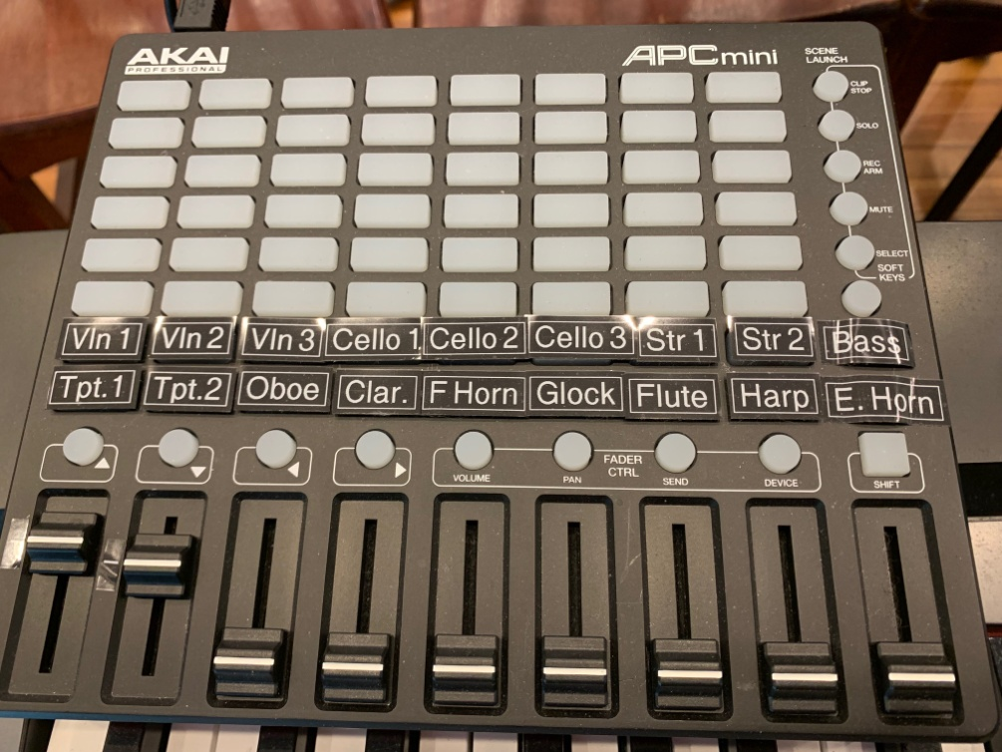

Here is a close up from the previous photo of the Akai APC mini midi controller which we “connected” to the East/West PLAY application from East/West Sounds. (You “connect them” by left clicking on the virtual sliders on the East/West PLAY application and select “MIDI learn”. The slider you next move on the actual Akai midi controller will now be learned by the application and linked to it. Be sure to RESAVE the file so you do not lose all of your new slider assignments.) We have one PLAY app. file on the desktop loaded with the top row of string solo samples (we made our own labels) and a second PLAY app. file on the computer desktop loaded with the second row of wind/etc. solo samples. We simply launch one file or the other, depending on what sound/s we will be using, and then use the correspondingly labeled Akai midi controller sliders to control the sample volumes.

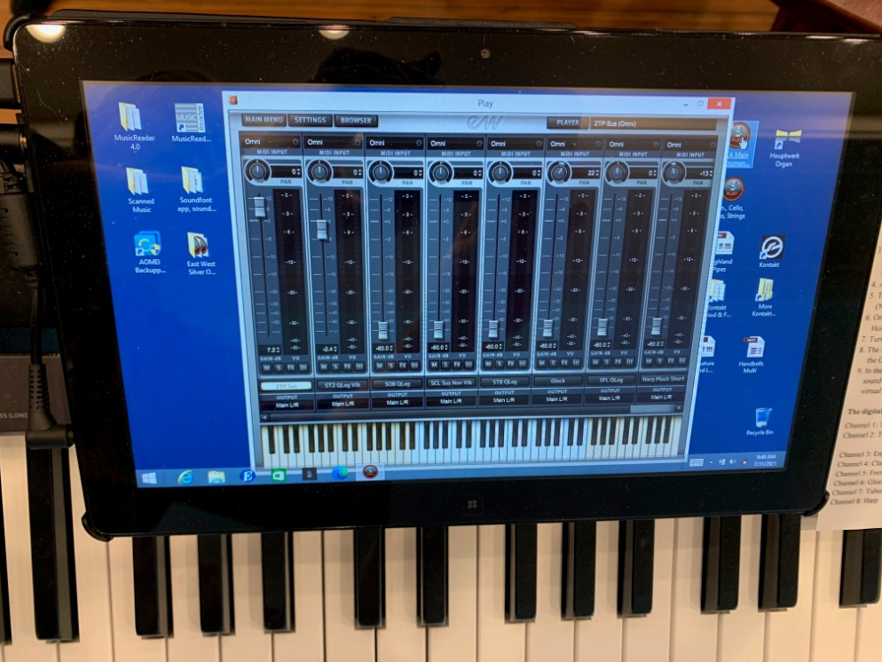
Here is a close up from photo #1 above of the virtual mixer on our Windows laptop using the East/West PLAY application. After using MIDI learn (as described in the previous photo), these virtual sliders link precisely with the actual sliders on the Akai midi controller pictured above.
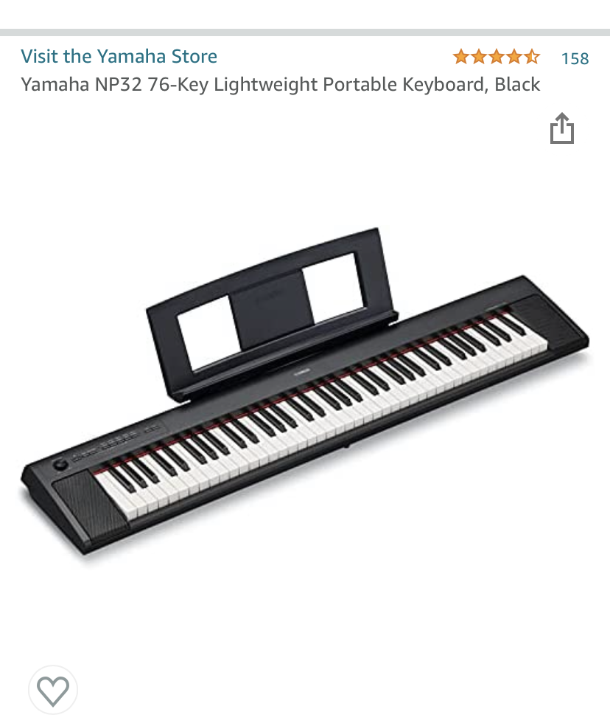

The Yamaha NP32 76-Key midi keyboard above is more than adequate for use as a midi controller for a digital orchestra. Plugged into a good sound system, or dedicated powered speakers as recommended at the top of this document, it has some very fine keyboard samples included with the keyboard. The touch is highly responsive and the Grand Piano samples are superb. So, you can have both a digital piano and a digital orchestra in one quality keyboard. For an 88-Key version of this keyboard see the photo below.
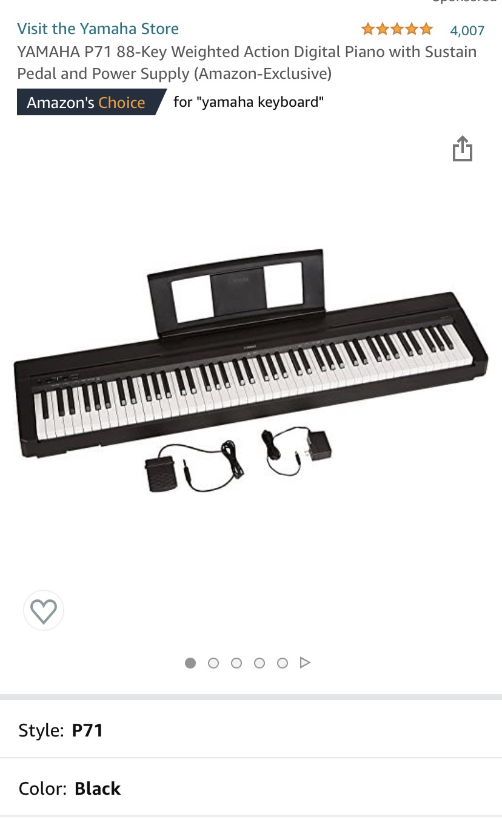

Below is the Casio Privia PX-770. This is the keyboard that we use with our digital orchestra rig. In fact, we own two of these and one of the Yamaha’s above. We like them equally well as they have good keyboard touch and excellent piano samples on board. The built-in speakers on the Casio are far better than those on the Yamaha. We often use them without additional amplification. On the other hand, the Yamaha keyboards pictured above are less expensive but not lower in quality for use as a midi controller keyboard for a digital orchestra. Admittedly, the on-board sounds are excellent as well, however, you will need to run them through larger/better speakers than the ones that are built into the instrument for use with a congregation or ensemble singers.
